STUDENT MARKS PREDICTION USING
LINEAR REGRESSION

Artificial Intelligence Project Report

Submitted by: IMRAN ALI HAIDER
Roll No: FA23-CSE-021
Program: Computer Systems Engineering
University: MUST
Submitted to: Engr. Dr. Ashfaq Ahmed
Course: Artificial Intelligence
Date: ____________________

CONTENTS
Page No.
ABSTRACT III
INTRODUCTION 1
1.1 BACKGROUND 1
1.2 MACHINE LEARNING AND REGRESSION 1
1.3 PROBLEM STATEMENT 1
1.4 OBJECTIVES 1
REVIEW OF LITERATURE 2
2.1 EARLY STUDIES ON STUDENT PERFORMANCE 1
2.2 MACHINE LEARNING FOR STUDENT MARKS PREDICTION 1
2.3 SUMMARY OF THE REVIEW 1
MATERIALS AND METHODS 3
3.1 TOOLS AND TECHNOLOGIES 3
3.2 DATASET DESCRIPTION 3
3.3 ALGORITHM AND MODEL DESIGN 3
3.4 EVALUATION METRICS 3
3.5 PYTHON SOURCE CODE 4
3.5.1 MODEL TRAINING AND EVALUATION (TRAIN_MODEL.PY) 4
3.5.2 STREAMLIT WEB INTERFACE (APP.PY) 5
3.6 PROGRAM OUTPUT 7
3.7 ETHICAL AND PRACTICAL LIMITATIONS 8
RESULTS 9
4.1 EVALUATION RESULTS 9
4.2 EXAMPLE PREDICTION AND GRAPH 9
DISCUSSION 10
5.1 MEANING OF THE EVALUATION RESULTS 10
5.2 EFFECT OF THE FEATURES 10
5.3 LIMITATIONS OF THE MODEL AND THE DATA 10
5.4 COMPARISON WITH OTHER WORK 11
CONCLUSIONS 12
RECOMMENDATIONS 13
APPENDIX A: HOW TO RUN THE PROJECT 14
APPENDIX B: ILLUSTRATIVE STUDENT RECORDS 15
REFERENCES 16

ABSTRACT
This project focuses on predicting student marks based on the number of hours they study each day using Machine Learning. Linear Regression is used to estimate marks because it can predict numerical values by learning from existing data. In this project, a small sample dataset is used to train and test the model. The model learns the relationship between study hours and marks and uses this relationship to predict marks for new study hours. A simple web interface is developed using Streamlit, where users can enter their daily study hours and view the predicted marks. The dataset used in this project is synthetic, meaning it is created for learning purposes and does not contain real student records. This project explains the basic steps of a Machine Learning system, including data preparation, model training, testing, performance evaluation, and application development.
Keywords: Machine Learning, Student Marks Prediction, Linear Regression, Study Hours, Model Training, Model Evaluation, Synthetic Dataset, Streamlit.

INTRODUCTION
Machine Learning is a part of Artificial Intelligence that enables computers to learn patterns from data and make predictions. Student performance can be affected by many factors, such as study habits, attendance, previous knowledge, and exam conditions. This project focuses on one input feature: daily study hours.
The purpose is to demonstrate how a regression model can learn a relationship between an input and a numerical output. The system is a learning project, not a tool for judging students or guaranteeing examination marks.

1.1 BACKGROUND
Student performance can be influenced by study habits, attendance, prior knowledge, and exam conditions. This project focuses on daily study hours as a simple example input to demonstrate a prediction workflow.

1.2 MACHINE LEARNING AND REGRESSION
Machine Learning enables a computer to identify patterns in data. Regression is used when the target is a numerical value. Linear Regression fits a straight line between study hours and marks and uses that relationship to estimate a mark for a given number of study hours.

1.3 PROBLEM STATEMENT
A beginner may find it difficult to understand how a Machine Learning model is prepared, trained, tested, and used to make a prediction. This project addresses that learning problem by building a small Python program that estimates marks from daily study hours. The dataset is illustrative and does not contain real student records.

1.4 OBJECTIVES
The objectives are to prepare a simple dataset, train a Linear Regression model, evaluate its predictions using MAE, RMSE, and R-squared, display actual and predicted values, and provide a small Streamlit interface for demonstration.

REVIEW OF LITERATURE
Regression is commonly used in statistics and Machine Learning to model relationships between variables. Linear Regression estimates a straight-line relationship between input features and a numerical target. Scikit-learn provides a LinearRegression implementation and functions for splitting data and evaluating predictions. Streamlit can be used to create an interactive web interface for a Python model.
This section provides brief technical background rather than a systematic literature review. The references at the end identify the main documentation and book used to support the project.

2.1 EARLIER WORK ON STUDENT PERFORMANCE
Research and educational data analysis commonly consider factors such as attendance, study time, previous achievement, and learning habits when examining student performance. These factors may be useful only when they are collected appropriately and interpreted in context.

2.2 MACHINE LEARNING FOR STUDENT MARKS PREDICTION
Supervised Machine Learning uses examples with known target values to learn a mapping from input features to outputs. Linear Regression is a basic method for numerical prediction and is useful for teaching the steps of data preparation, model fitting, testing, and evaluation. This project uses study hours as its only input feature.

2.3 SUMMARY OF THE REVIEW
The technical sources listed in the References section support the use of Linear Regression, model-evaluation metrics, and Streamlit for a simple demonstration. The present project is an educational example rather than a comprehensive study of real student performance.

MATERIALS AND METHODS

3.1 Tools and Technologies
- Python: used to write and run the project programs.
- Pandas: used to load and manage the CSV dataset.
- NumPy: used for numerical calculations, including RMSE.
- Scikit-learn: used for data splitting, Linear Regression, and evaluation metrics.
- Streamlit: used to create the interactive web interface.
- Matplotlib: used to plot the sample data and fitted regression line.
- Visual Studio Code, IDLE, or another Python editor may be used; a terminal is required to run the commands.

3.2 Dataset Description
The dataset file student_marks.csv contains 30 illustrative records and two columns: study_hours and marks. The study_hours column is the input feature, while marks is the target value measured out of 100. These are synthetic demonstration values and were not collected from real students.
Column | Type | Description
study_hours | Numeric | Daily study hours; input feature
marks | Numeric | Illustrative marks out of 100; target value

3.3 Algorithm and Model Design
Linear Regression learns a line that relates study hours to marks. In simple form, the prediction is calculated as y = b₀ + b₁x, where x represents study hours, b₀ is the intercept, and b₁ is the learned coefficient. The dataset is divided into 80% training data and 20% testing data. random_state=42 is used so that the training/testing split can be reproduced.

3.4 Evaluation Metrics
Mean Absolute Error (MAE) is the average absolute difference between actual and predicted marks. Root Mean Squared Error (RMSE) is the square root of the average squared prediction error and gives more weight to larger errors. R-squared (R²) describes how well the model predictions fit the test targets. These metrics describe only this synthetic dataset and this particular split.

3.5 Python Source Code
The following source code is part of the Materials and Methods section so that the implementation can be reviewed alongside the procedure. The programs read student_marks.csv from the same folder.

3.5.1 Model Training and Evaluation (train_model.py)
import pandas as pd
import numpy as np
from sklearn.model_selection import train_test_split
from sklearn.linear_model import LinearRegression
from sklearn.metrics import mean_absolute_error, mean_squared_error, r2_score

# Load the illustrative dataset
data = pd.read_csv("student_marks.csv")
X = data[["study_hours"]]
y = data["marks"]

# Split into training (80%) and testing (20%) sets
X_train, X_test, y_train, y_test = train_test_split(
X, y, test_size=0.2, random_state=42
)

# Train the model and predict the test rows
model = LinearRegression()
model.fit(X_train, y_train)
predictions = model.predict(X_test)

print("Results on illustrative sample data")
print(f"Mean Absolute Error (MAE): {mean_absolute_error(y_test, predictions):.2f} marks")
print(f"Root Mean Squared Error (RMSE): {np.sqrt(mean_squared_error(y_test, predictions)):.2f} marks")
print(f"R-squared (R2): {r2_score(y_test, predictions):.3f}")
print("\\nActual vs predicted:")
for actual, predicted in zip(y_test.tolist(), predictions.tolist()):
print(f"Actual: {actual:>5.1f} | Predicted: {predicted:>5.1f}")
import matplotlib.pyplot as plt

3.5.2 Streamlit Web Interface (app.py)
import streamlit as st
import pandas as pd
from sklearn.linear_model import LinearRegression

st.set_page_config(page_title="Student Marks Predictor", page_icon="📘")
st.title("Student Marks Prediction")
st.write("Enter daily study hours to get an estimated mark.")
st.warning("Learning demo only: this uses synthetic sample data, not real student records.")

@st.cache_resource
def train_model():
data = pd.read_csv("student_marks.csv")
model = LinearRegression()
model.fit(data[["study_hours"]], data["marks"])
return model

model = train_model()
hours = st.number_input(
"Daily study hours",
min_value=0.0,
max_value=16.0,
value=4.0,
step=0.5
)

if st.button("Predict Marks"):
sample = pd.DataFrame({"study_hours": [hours]})
prediction = float(model.predict(sample)[0])
prediction = max(0.0, min(100.0, prediction))
st.metric("Estimated marks out of 100", f"{prediction:.1f}")
st.caption("This is an estimate, not a guarantee of actual exam marks.")

st.subheader("Illustrative dataset")
st.dataframe(pd.read_csv("student_marks.csv"), use_container_width=True)
# Linear Regression Graph
data = pd.read_csv("student_marks.csv")

fig, ax = plt.subplots(figsize=(8, 5))

# Actual data points
ax.scatter(
data["study_hours"],
data["marks"],
color="blue",
label="Actual Marks"
)

# Linear Regression line
x_values = pd.DataFrame({
"study_hours": sorted(data["study_hours"])
})

y_values = model.predict(x_values)

ax.plot(
x_values["study_hours"],
y_values,
color="red",
linewidth=2,
label="Linear Regression Line"
)

ax.set_xlabel("Daily Study Hours")
ax.set_ylabel("Marks")
ax.set_title("Study Hours vs Marks - Linear Regression")
ax.legend()
ax.grid(True)

st.subheader("Linear Regression Graph")
st.pyplot(fig)

3.6 Program Output
The training program was executed using the supplied illustrative dataset and the fixed 80/20 split.
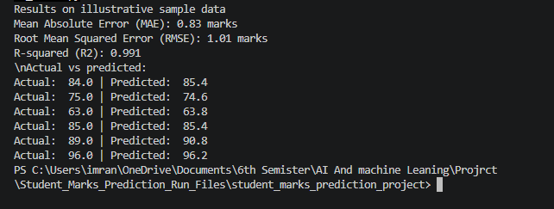

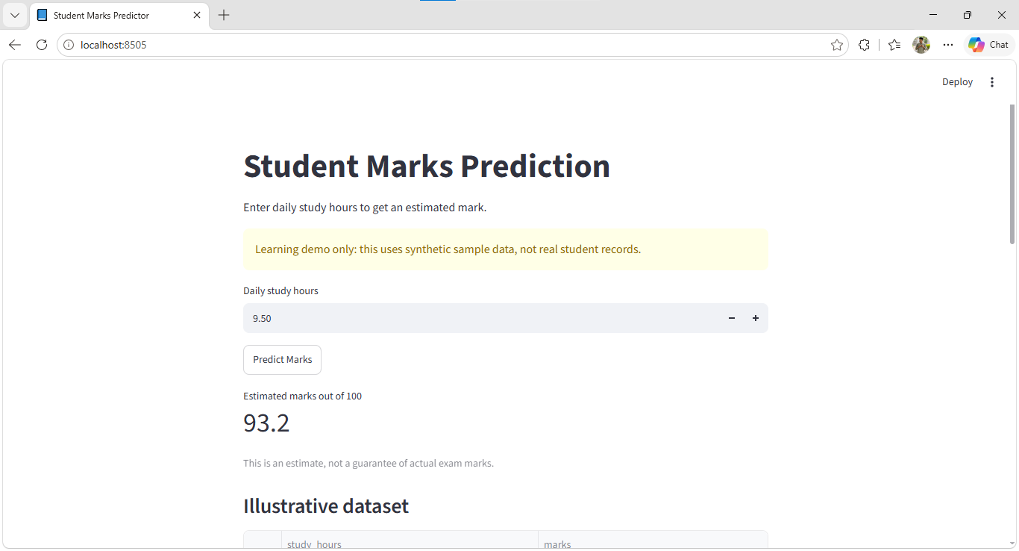

3.7 Ethical and Practical Limitations
The dataset is small and synthetic, and study hours alone cannot accurately predict a real student’s performance. The application must not be used for academic decisions. A stronger project could use a larger, approved dataset and relevant features such as attendance or previous marks, while respecting privacy and permission requirements.

RESULTS

4.1 Evaluation Results
The model was trained on 80% of the 30 records (24 rows) and tested on the remaining 20% (6 rows). The measured results from this run are shown below.
Metric | Result | Interpretation
Mean Absolute Error (MAE) | 0.83 marks | Average absolute prediction error
Root Mean Squared Error (RMSE) | 1.01 marks | Penalizes larger errors more strongly
R-squared (R²) | 0.991 | Fit score for this test split

These results indicate that the model fits the illustrative data closely. They do not prove that the model will predict actual student marks with the same accuracy.

4.2 Example Prediction and Graph
For an example, enter 9.50 daily study hours in the Streamlit interface and click Predict Marks. The displayed value is an estimate calculated by the model and is not a guarantee of examination performance.
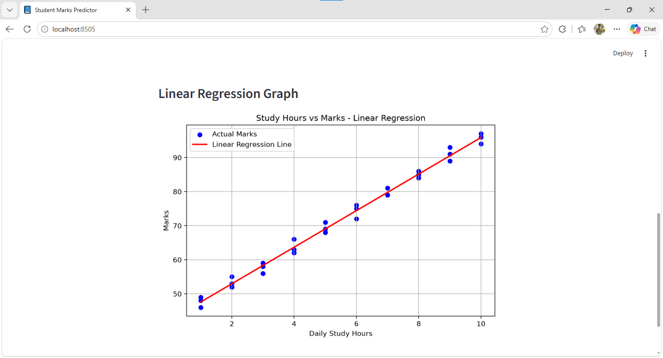
Figure 1. Linear Regression line fitted to the illustrative sample data.

DISCUSSION
The project demonstrates a simple end-to-end Machine Learning workflow: loading data, selecting the input and target, splitting the dataset, training a model, evaluating predictions, and showing an estimate through a web interface. The interface makes the model easier to demonstrate without manually entering Python commands for each prediction. However, the dataset is artificial and contains only one input feature, so the results are only for educational demonstration.
5.1 MEANING OF THE EVALUATION RESULTS
The evaluation results help explain how well the Linear Regression model performed when predicting student marks. The project follows a basic Machine Learning workflow, which includes loading the dataset, selecting the input and target variables, splitting the data into training and testing sets, training the model, and evaluating its predictions.
The model's performance is measured using evaluation metrics that show the difference between actual marks and predicted marks. Lower prediction errors indicate that the model's predictions were closer to the actual values in the tested data. However, the results only describe the performance on the particular dataset split used in this project. They do not guarantee the same performance on other datasets or real student records.
5.2 EFFECT OF THE STUDY-HOURS FEATURE
Daily study hours are the only input feature used by the model to estimate student marks. During training, the model learns the relationship between the number of study hours and the marks provided in the dataset. It then uses this learned relationship to predict marks for a new number of study hours entered by the user.
Using only one feature makes the project simple and easy to understand. However, students' academic performance depends on several factors, not only study time. Attendance, previous academic performance, understanding of the subject, study methods, and exam difficulty may also affect marks. Since these factors are not included in the dataset, the model cannot consider their effects when making predictions.
5.3 LIMITATIONS OF THE MODEL AND DATA
The main limitation of this project is the small dataset, which contains only 30 synthetic records. These records are created for educational purposes and do not represent actual student information. Therefore, the model may learn a relationship that does not accurately represent the performance of real students.
Another limitation is that the model uses only daily study hours to predict marks. It cannot consider other academic or personal factors that may influence examination results. In addition, the performance of the model depends on the quality and variety of the available data.
5.4 COMPARISON WITH OTHER WORK
This project is a basic educational demonstration of Linear Regression for student marks prediction. Its main purpose is to explain how a Machine Learning model can be trained, evaluated, and connected to a simple web application. It is not designed as a formal comparison with other published student-performance prediction systems.

CONCLUSION
This project demonstrates how Machine Learning can be used to estimate student marks based on daily study hours using Linear Regression. Python is used for data preparation, model training, testing, and performance evaluation. A Streamlit web interface allows users to enter study hours and view predicted marks.
The project provides a basic understanding of Machine Learning and its practical applications. However, the dataset is synthetic and does not represent real student records. The model could be improved in the future by using a larger dataset and including additional factors such as attendance and previous academic performance.

RECOMMENDATIONS
Based on this project, several improvements can be made to achieve better prediction results and improve the overall system.
- A larger and genuine dataset should be used if the model is intended for real-world predictions. The data should be collected with proper permission.
- The dataset should be checked for missing values, incorrect entries, and other errors before training the model.
- Other factors, such as attendance and previous academic marks, may be included to help the model make better predictions, provided the data is collected ethically.
- Linear Regression can be compared with other suitable regression algorithms to evaluate which model performs better.
- The Python training program and Streamlit interface should be tested locally to ensure that the model runs correctly and displays predictions properly.
- A screenshot of the running Streamlit application should be included in the report to show how users enter study hours and view predicted marks.

APPENDIX A: HOW TO RUN THE PROJECT
The following steps explain how to set up and run the Student Marks Prediction project on a computer.
1. Install Python: Install Python 3.10 or a newer version. Python is required to execute the machine learning code.
2. Open the Project Folder: Open a terminal or command prompt in the folder containing the project files.
3. Create a Virtual Environment: Run the following command to create a separate environment for the project’s Python packages.
python -m venv .venv
4. Activate the Virtual Environment: On Windows, run the following command to activate it.
.venv\Scripts\activate
5. Install Required Libraries: Run the command below to install all the required Python packages listed in requirements.txt.
pip install -r requirements.txt
6. Train the Machine Learning Model: Run the following command to execute the training script. It trains the model and displays evaluation metrics to help assess its performance.
python train_model.py
7. Launch the Web Application: Run the following command to start the Streamlit web interface. It allows users to interact with the Student Marks Prediction project through a browser.
streamlit run app.py
After completing these steps, the project should be ready to run, provided all required files and dependencies are available

APPENDIX B: ILLUSTRATIVE STUDENT RECORDS
The following 30 rows are synthetic demonstration records. They are not collected from real students. The same rows are supplied in student_marks.csv and are used by both Python programs.
Record No. | Study Hours per Day | Marks (out of 100)
1 | 1.0 | 49.0
2 | 2.0 | 52.0
3 | 3.0 | 59.0
4 | 4.0 | 62.0
5 | 5.0 | 69.0
6 | 6.0 | 76.0
7 | 7.0 | 79.0
8 | 8.0 | 86.0
9 | 9.0 | 89.0
10 | 10.0 | 96.0
11 | 1.0 | 48.0
12 | 2.0 | 53.0
13 | 3.0 | 56.0
14 | 4.0 | 66.0
15 | 5.0 | 68.0
16 | 6.0 | 75.0
17 | 7.0 | 79.0
18 | 8.0 | 85.0
19 | 9.0 | 93.0
20 | 10.0 | 94.0
21 | 1.0 | 46.0
22 | 2.0 | 55.0
23 | 3.0 | 58.0
24 | 4.0 | 63.0
25 | 5.0 | 71.0
26 | 6.0 | 72.0
27 | 7.0 | 81.0
28 | 8.0 | 84.0

REFERENCES
[1] Scikit-learn developers, “LinearRegression,” Scikit-learn documentation. Available: https://scikit-learn.org/stable/modules/generated/sklearn.linear_model.LinearRegression.html
[2] Scikit-learn developers, “Model evaluation: quantifying the quality of predictions,” Scikit-learn documentation. Available: https://scikit-learn.org/stable/modules/model_evaluation.html
[3] Streamlit, “Get started,” Streamlit documentation. Available: https://docs.streamlit.io/get-started
[4] W. McKinney, Python for Data Analysis, 3rd ed. O’Reilly Media, 2022.

